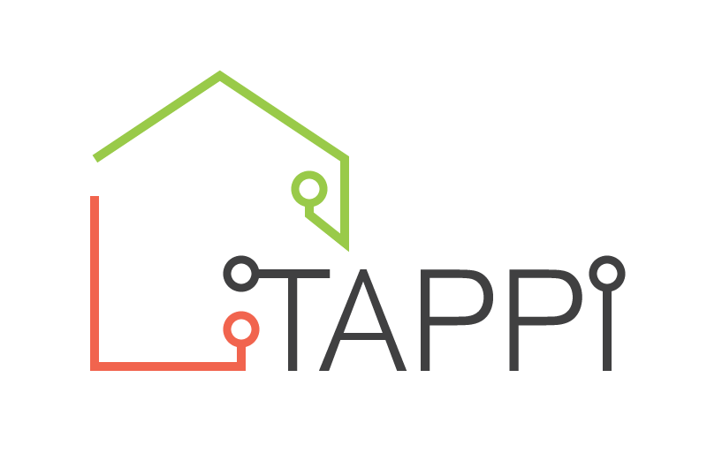
Embargo: 12.00hrs Tuesday, 29 March 2022

PRESS RELEASE

Social landlords urged to bid for technology testbed funding, so homes are ‘care ready’

Housing associations and local authorities are being invited to apply for grants of £75,000 so they can test out with older people which technology tools and digital housing services work best for them and explore why.

The funding is part of the Technology for our Ageing Population: Panel for Innovation (TAPPI) project - led by the Housing Learning and Improvement Network (Housing LIN), the TEC Services Association (TSA) and funded by the Dunhill Medical Trust - which is calling for ‘care-ready’ digital infrastructure to be woven into the fabric of all new and retrofitted homes, right from design stage.

The first phase of TAPPI concluded in 2021, examining current practice and then setting out ten practical principles for using technology in housing and care for older people. The second phase will trial the use of these principles in people’s homes over a 12 - 15 month period.

A wide range of organisations, including providers of social housing, supported living services, grouped living schemes and step-down dwellings that support reablement are all eligible to apply for funding to become demonstrator sites, as are those that support older people to live independently at home.

Four organisations will each be awarded a grant of £75,000 so they can try out different mainstream and specialist technologies with older people, gathering their feedback.

Digital services and solutions will be assessed using TAPPI principles to ensure they are: Adaptable, Co-produced, Cost-effective, Choice-led, Interoperable, Inclusive, Outcome-focused, Person-Centred, Preventative and Quality-focused.

Each demonstrator site will share their findings throughout the project, reporting on people’s views, barriers to using digital services, what worked well and how easy it was to embed the TAPPI principles when building and retrofitting homes.

The Housing LIN, the TEC Services Association (TSA) and the Dunhill Medical Trust will use case studies and learnings from the project to support other housing providers that are seeking to adopt the TAPPI principles and make their homes ‘care ready’.

Jeremy Porteus, CEO of the Housing Learning and Improvement Network (Housing LIN) said: "I am really excited about TAPPI2 and embedding the principles identified in last year's Inquiry into practice. With co-production at the heart of TAPPI, we’re keen to work with older people to find out what technology-enabled care and housing solutions support them best. The results will offer vital information on how technology can be better applied in homes for our ageing population."

Alyson Scurfield, CEO of the TEC Services Association (TSA) said: “Although some housing providers are already supporting older people through tech, it’s a patchwork of provision, not an organised or transformational system, adopted across the sector. We want to change that through TAPPI, testing digital solutions and then creating guidance, standards and a widely accepted framework so housing providers, architects and builders can integrate tech into housing and make life more fulfilling for our ageing population.”

Susan Kay, CEO of the Dunhill Medical Trust said: “We view enabling technology as a vital element of supporting people to remain as independent as possible in their own homes and communities as they age, so this programme is much broader than simply evaluating the impact of the digital upgrade of a scheme’s alarm systems, for example. We’re looking for practical, holistic solutions that enable people to choose and control the support they want so they can do the things they love, in the communities they call home.”

For further details on how to apply, visit: https://dunhillmedical.org.uk/apply-for-funding/ . The closing date for applications is 16 May 2022.

ENDS

Media enquiries: Rowan Atkins M: 07834 158 725 E: rowan@rowanatkins.co.uk

Editor’s Notes:

TAPPI
Find out more about TAPPI and its ten principles here:
https://www.housinglin.org.uk/TAPPI

Housing LIN
The Housing Learning and Improvement Network (LIN) is a sophisticated network bringing together housing, health and social care professionals in England, Wales, and Scotland to exemplify innovative housing solutions for an ageing population. The Housing LIN is recognised by government and the housing with care sector as a leading ‘knowledge hub’ on specialist housing.
www.housinglin.org.uk

TSA
The Technology Enabled Care (TEC) Services Association is the representative body for technology enabled care (TEC) services across the UK, working on behalf of and advising organisations including telecare and telehealth service providers, suppliers, housing associations, care providers, emergency services, academia, charities, government bodies and health and social care commissioners.
www.tsa-voice.org.uk

The Dunhill Medical Trust
The Dunhill Medical Trust funds the remarkable science and the radical social change needed for healthier older age. The Trust invests in those who have great ideas and methods for improving the health and well-being of older people and in making the connections which can help them to flourish.
www.dunhillmedical.org.uk

